CHAPTER-1
INTRODUCTION
  - Overview
Joint health is one of the most important aspects of human mobility and overall quality of life. Problems such as osteoarthritis, ligament injuries, and cartilage degeneration are becoming increasingly common among both elderly individuals and younger people, including athletes. At present, doctors mainly depend on diagnostic methods such as X-rays, MRI scans, and ultrasound to assess joint conditions. While these techniques provide valuable structural details, they are expensive, time-consuming, and unsuitable for continuous or everyday monitoring. Vibroarthrography (VAG) is a non-invasive method that focuses on analysing the vibrations and sounds produced by joints during movement. These signals can reveal early signs of abnormalities in joint function before permanent structural damage occurs. This project, titled “IoT-Integrated VAG Signal Analysis for Real-Time Joint Health Assessment,” aims to design and implement a system that collects VAG signals using wearable sensors, processes them with suitable algorithms, and classifies the results using machine learning models. The integration of IoT allows this information to be transmitted in real time, enabling both patients and doctors to monitor joint health continuously.
Moreover, such a system can empower patients with timely insights about their mobility and recovery progress, reducing the dependency on frequent hospital visits. For athletes, it can serve as an early-warning tool to prevent overuse injuries and optimize training loads. In the elderly population, continuous monitoring can support early detection of degenerative conditions, allowing for lifestyle adjustments and medical interventions at the right time. The real-time nature of IoT connectivity ensures that clinicians can track long-term trends and receive alerts whenever abnormal joint activity is detected. Ultimately, this integration of VAG and IoT not only advances preventive healthcare but also contributes to a more personalized, accessible, and cost-effective approach to joint health management.

  - Research Motivation
The growing number of people affected by joint disorders highlights the need for more practical and accessible methods of diagnosis. Traditional medical imaging is reliable but not feasible for routine or preventive monitoring, especially in rural areas or for elderly patients. Athletes and individuals undergoing rehabilitation also require continuous feedback on joint condition, which is not possible with existing methods.
By integrating VAG analysis with IoT, this project seeks to provide real-time and remote monitoring of joint health. Such a system can support preventive care, reduce unnecessary hospital visits, and give healthcare professionals continuous access to patient data for better decision-making.
  - Problem statement
To develop an IoT-enabled system capable of capturing and analyzing VAG signals in real time, classifying joint health status, and providing a continuous, non-invasive, and cost-effective method for monitoring joint health outside clinical environments.

  - Significance
- Offers a non-invasive and portable solution for joint monitoring.
- Provides real-time assessment to detect abnormalities at an early stage.
- Supports remote healthcare and telemedicine, reducing dependency on frequent hospital visits.
- Improves patient outcomes by enabling preventive care and early diagnosis.
- Helps doctors and patients track progress during rehabilitation and recovery.
  - Objective
The main objectives of this project are:
- To acquire VAG signals using wearable sensors during joint movements.
- To filter and process these signals for noise removal and feature extraction.
- To apply machine learning models for classifying joint conditions as normal or abnormal.
- To integrate IoT frameworks for transmitting and visualizing the processed data in real time.
- To design a scalable and user-friendly system suitable for both clinical and home-based applications.
  - Advantages
- Provides continuous and real-time monitoring of joint health instead of one-time clinical examinations.
- Offers a non-invasive and patient-friendly approach, avoiding radiation or invasive tests.
- Enables early detection of joint abnormalities before severe structural damage occurs.
- Reduces dependency on expensive imaging techniques like MRI and X-rays for regular check-ups.
- Supports remote healthcare and telemedicine, giving doctors access to patient data anytime, anywhere.
- Improves patient compliance by using lightweight, portable wearable devices.
- Helps in tracking rehabilitation progress, allowing therapists to monitor recovery after surgery or injury.
- Lowers long-term healthcare costs by promoting preventive care and reducing hospital visits.
- Ensures data storage and analysis through IoT platforms, which supports record-keeping and trend analysis.
- Provides a scalable and adaptable system that can be extended to different types of joint monitoring.
  - Applications
- Hospitals and Clinics – Assisting doctors in diagnosing and monitoring patients with joint disorders.
- Sports Medicine – Tracking joint stress in athletes and detecting early signs of sports-related injuries.
- Rehabilitation Centers – Monitoring progress of patients recovering from joint surgery or therapy.
- Elderly Care – Providing continuous home-based monitoring for age-related degenerative conditions.
- Telemedicine Platforms – Allowing healthcare professionals to remotely access real-time patient data.
- Personal Health Monitoring – Enabling individuals to self-track their joint condition for preventive care.
- Rural Healthcare – Offering affordable diagnostic support in areas with limited medical infrastructure.
- Research and Clinical Trials – Providing objective data for studies related to joint disorders and treatments.
- Occupational Health – Monitoring workers in industries with high physical strain to prevent long-term injuries.
- Fitness and Wellness Programs – Assisting in evaluating joint health as part of overall physical fitness tracking.

CHAPTER 3
LITERATURE SURVEY

- Kernohan WG et.al [1] Technique has been used in early detection of congenital dislocation of the hip and also in diagnosis of meniscal pathology. More recently, patellar vibration has been used to assess the mechanical properties of articular cartilage. Vibration arthrometry has also yielded new information on a possible damage mechanism associated with shock vibration that arises during cavitation of synovial fluid. Joint vibrations are therefore useful aids to diagnosis and may even be etiologic in orthopedic disease.
- Haugen IK et.al [3] As associated with reduced knee cartilage thickness (ß = -0.02, 95% CI -0.03, -0.01) in the medial femorotibial compartment, while hand osteophytes were associated with the presence of radiographic knee OA (OR 1.10, 95% CI 1.03-1.18; multivariate models) with both hand OA features as independent variables adjusted for age, sex, and BMI). Radiographic features of hand OA were not associated with 1-year cartilage thinning or radiographic knee OA progression.
- Patel, S., Park, H., Bonato, P. et.al.[5] The aim of this review paper is to summarize recent developments in the field of wearable sensors and systems that are relevant to the field of rehabilitation. The growing body of work focused on the application of wearable technology to monitor older adults and subjects with chronic conditions in the home. A short description of key enabling technologies (i.e. sensor technology, communication technology, and data analysis techniques) that have allowed researchers to implement wearable systems is followed by a detailed description of major areas of application of wearable technology.
- C. Bellos, A. Papadopoulos, R. Rosso and D. I.et.al.[7] The CHRONIOUS platform is validated through clinical trials in several medical centers and patient's home environments recruiting patients suffering from Chronic Obstructive pulmonary disease (COPD) and Chronic Kidney Disease (CKD) diseases. The results of the utilization of the system were very encouraging. The CHRONIOUS system has been proven to be a well-validated real-time patient monitoring and supervision platform, providing a useful tool for the clinician and the patient that would contribute to the more effective management of chronic diseases.
- Conconi M et.al [8] Found a significant correlation between joint congruence and sex due to the sex-related differences in size. The observed correlation disappeared after normalization. Although joint congruence increased with size, it did not correlate significantly with the onset of early OA. Differences in joint congruence in this population may not be a primary cause of OA onset or predisposition, at least for the CMC joint.
- N. Abdela el.al.[11],Sub-acute ruminal acidosis (SARA) and its consequence in dairy cattle: A review of past and recent research at global prospective (2016), pp. 187-196. To better understand the temporal and spatial dynamics of the rumen environment, real-time and in situ monitoring of various chemical and physical parameters in the rumen through implantable microsensor technologies is a practical solution. Moreover, such sensors could contribute to the next generation of precision livestock farming, provided sufficient wireless data networking and computing systems are incorporated.
- Drover D, Howcroft J, Kofman J, Lemaire ED. et.al. [12] The best “classifier model—feature selector” combination used turn data, random forest classifier, and select-5-best feature selector (73.4% accuracy, 60.5% sensitivity, 82.0% specificity, and 0.44 Matthew’s Correlation Coefficient (MCC)). Using only the most frequently occurring features, a feature subset (minimum of anterior-posterior ratio of even/odd harmonics for right shank, standard deviation (SD) of anterior left shank acceleration SD, SD of mean anterior left shank acceleration, maximum of medial-lateral first quartile of Fourier transform (FQFFT) for lower back, maximum of anterior-posterior FQFFT for lower back) achieved better classification results, with 77.3% accuracy, 66.1% sensitivity, 84.7% specificity, and 0.52 MCC score.
- Campuzano S, Yáñez-Sedeño P, Pingarrón JM.et.al[13]The tremendous potential offered by electrochemical affinity biosensors to detect on-site infectious pathogens at clinically relevant levels in scarcely treated body fluids is clearly stated in this review. The development and application of selected examples using different specific receptors, assay formats and electrochemical approaches focusing on the determination of specific circulating biomarkers of different molecular (genetic, regulatory and functional) levels associated with bacterial and viral pathogens are critically discussed. Existing challenges still to be addressed and future directions in this rapidly advancing and highly interesting field are also briefly pointed out.
- Faisal AI, el.al. [16]. Monitoring Methods of Human Body Joints: State-of-the-Art and Research Challenges. Sensors. 2019. A viable monitoring system can be developed by combining miniaturized, durable, low-cost and compact sensors with the advanced communication technologies and data processing techniques.A discussion on sensors’ data processing, interpretation, and analysis techniques is also presented. Finally, current research focus, as well as future prospects and development challenges in joint monitoring systems are discussed.
- Rehouma H, el.al.[18]. Advancements in Methods and Camera-Based Sensors for the Quantification of Respiration. Sensors. 2020; 20(24):7252. Most of these works require physical contact with the patient to produce accurate and reliable measures of the respiratory function. There is still a significant shortcoming of non-contact measuring systems in their ability to fit into the clinical environment.A classification of the applicable research works is presented according to their techniques and recorded/quantified respiration parameters. In addition, the current solutions are discussed with regards to their direct applicability in different settings, such as clinical or home settings, highlighting their specific strengths and limitations in the different environments
- Łysiak-A, et.al [19] Results were compared to state-of-the-art frequency features using the Bhattacharyya coefficient and the set of ten different classification algorithms. All methods evaluating proposed features indicated the superiority of the new features compared to the state-of-the-art. In terms of Bhattacharyya coefficient, newly proposed features proved to be over 25% better, and the classification accuracy was on average 9% better.
- Ponsiglione AM, el.al.[25]. A Comprehensive Review of Techniques for Processing and Analyzing Fetal Heart Rate Signals. Sensors. 2021; 21(18):6136. The objective of this review is to describe the techniques, methodologies, and algorithms proposed in this field so far, reporting their main achievements and discussing the value they brought to the scientific and clinical community. The review explores the following two main approaches to the processing and analysis of FHR signals: traditional (or linear) methodologies, namely, time and frequency domain analysis, and less conventional (or nonlinear) techniques are also discussed with a specific focus on the use of Artificial Neural Networks, whose application to the analysis of accelerations in FHR signals is also examined in a case study conducted by the authors
- Karpiński R, el.al. [34]. Diagnostics of Articular Cartilage Damage Based on Generated Acoustic Signals Using ANN—Part II: Patellofemoral Joint. Sensors. 2022; 22(10):3765. The purpose of this study was to evaluate the proposed examination and acquisition protocol for the patellofemoral joint, as well as to determine the optimal examination protocol to obtain the best diagnostic results. Both closed (CKC) and open (OKC) kinetic chains were assessed during VAG. The selection of the optimal signal measures was performed using a neighborhood component analysis (NCA) algorithm.
- Abdulmalek S, el.al.[35]. IoT-Based Healthcare-Monitoring System towards Improving Quality of Life: A Review. Healthcare. 2022; 10(10):1993. This review paper explores the latest trends in healthcare-monitoring systems by implementing the role of the IoT. The work discusses the benefits of IoT-based healthcare systems with regard to their significance, and the benefits of IoT healthcare. We provide a systematic review on recent studies of IoT-based healthcare-monitoring systems through literature review.The paper also explores wireless- and wearable-sensor-based IoT monitoring systems and provides a classification of healthcare-monitoring sensors. We also elaborate, in detail, on the challenges and open issues regarding healthcare security and privacy, and QoS.
- Upadhyay HK, et.al[40] AHP is a flexible strategy for organizing and simplifying complex MCDM concerns by disassembling a compound decision problem into an ordered array of relational decision components (evaluation criteria, sub-criteria, and substitutions. “Distress” has proven itself the most critical IoT-related ergonomics-based healthcare issue, followed by obesity, depression, and exhaustion. These IoT-related ergonomics-based healthcare issues in four categories (excruciating issues, eye-ear-nerve issues, psychosocial issues, and persistent issues) have been compared and ranked.In several industrial systems, the results may be of vital importance for increasing the efficiency of human force, particularly a human–computer interface for prolonged hours.
- Nichols CJ, et.al[55] :Acoustic features selected for use in the optimized models had high test-retest reliability by intrasession and intersession intraclass correlation analysis (mean intraclass correlation coefficient 0.971 +/− 0.08 standard deviation). Analysis of KAE measured in acoustically uncontrolled medical settings using an easily accessible wearable device accurately classified pre-OA knees from healthy control knees in our small cohort. Accessible methods of identifying pre-OA could enable regular joint health monitoring and improve OA treatment and rehabilitation outcomes.
- Chunyan Li, et.al [56]:This includes addressing data security concerns, ensuring seamless interoperability, and optimizing the use of IoT-generated data. The paper seeks to inspire practitioners and researchers by highlighting the practical implications of IoT in healthcare, emphasizing the ways IoT can enhance patient care, resource allocation, and overall healthcare efficiency.
- Karpiński R, el.al. [2]. Vibroarthrography as a Noninvasive Screening Method for Early Diagnosis of Knee Osteoarthritis: A Review of Current Research. Applied Sciences. 2025; 15(1):279. In order to implement quick and effective treatment and prevent the development of the disease, accurate and early diagnosis is important. The paper reviews recent studies on vibroarthrography as a diagnostic method for knee osteoarthritis. The aim of the study is to organise the current knowledge regarding the diagnosis of osteoarthritis of the knee joint and vibroarthrography as a proposal for a new diagnostic method.
- Machrowska A, el.al.[1]. Multi-Scale Analysis of Knee Joint Acoustic Signals for Cartilage Degeneration Assessment. Sensors. 2025. With each of the functions resulting from the analysis reflecting local variations in the amplitude and frequency over time and allowing for effective removal of noise present in the signal. The CNN model is trained on features extracted from these signals to accurately classify different stages of cartilage degeneration. The proposed method demonstrates the potential for early detection of knee joint pathology, providing a valuable tool for preventive healthcare and reducing the need for invasive diagnostic procedures. The results suggest that the combination of EEMD-DFA for feature extraction and CNN for classification offers a promising approach for the non-invasive assessment of cartilage damage.

3.2 PROPOSED SYSTEM
3.2.1 Overview
The proposed system focuses on the integration of IoT and Vibroarthrography (VAG) signal analysis to enable real-time and continuous monitoring of joint health. The system uses wearable sensors placed near the knee joint to capture vibration and acoustic signals generated during movement. These raw signals undergo preprocessing to remove noise and motion artifacts. Extracted features are then classified by a machine learning model to distinguish between normal and abnormal joint conditions. The classified results are transmitted through an IoT framework to cloud platforms, where patients and doctors can access the information via mobile or web interfaces. The system is designed to be non-invasive, portable, cost-effective, and scalable, making it suitable for home-based monitoring, clinical use, rehabilitation,
. 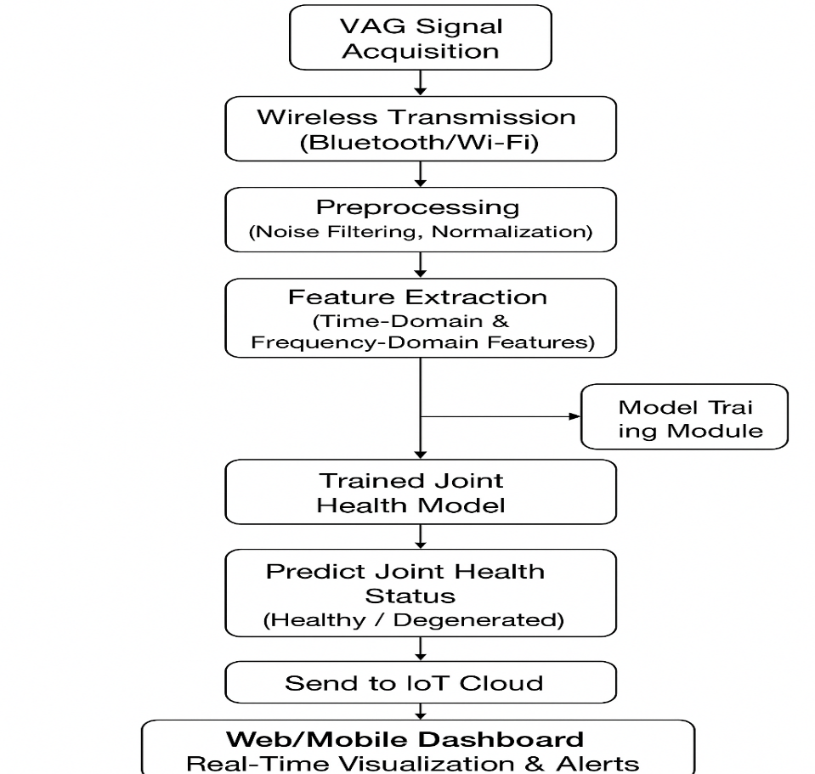
Fig 4.1: proposed blocked diagram

3.2.2 Preprocessing
VAG signals are naturally prone to external noise, motion artifacts, and inconsistencies due to variations in movement. Preprocessing is a critical step to ensure that the input to the machine learning model is clean and reliable. The following preprocessing techniques are applied in the proposed system:
- Filtering
- A band-pass filter is used to isolate frequencies in the range typically associated with joint sounds (e.g., 50–1,000 Hz).
- Helps eliminate irrelevant low-frequency motion artifacts and high-frequency environmental noise.
- Denoising
- Techniques such as Wavelet Transform Denoising or Moving Average Filtering are applied.
- This reduces random noise while preserving the essential characteristics of the joint vibrations.
- Segmentation
- Continuous signals are segmented into smaller windows based on movement cycles (e.g., flexion/extension).
- This ensures that features are extracted from meaningful portions of the signal.
- Normalization
- Amplitude normalization is performed so that variations in sensor placement or patient movement intensity do not distort the analysis.
- Feature Preparation
- Preprocessed signals are converted into structured datasets (time-domain and frequency-domain features) for further analysis.
3.2.3 Exploratory Data Analysis (EDA)
Exploratory Data Analysis is carried out to study the behavior of Vibroarthrography (VAG) signals before applying machine learning models. The purpose of EDA is to understand the patterns, frequency ranges, and statistical properties of the signals that distinguish healthy joints from abnormal ones.
- Time-Domain Analysis
  - VAG signals recorded during joint motion show distinct patterns.
  - Healthy joints produce smooth, low-amplitude vibrations, while abnormal joints exhibit irregular, high-amplitude bursts.
- Frequency-Domain Analysis
  - Using Fast Fourier Transform (FFT), the spectral components of the signal are examined.
  - Healthy joints usually have lower energy in high-frequency bands, whereas diseased joints display scattered spectral peaks.
- Statistical Observations
  - Variance, skewness, kurtosis, and entropy are calculated for each signal window.
  - Clear statistical differences are observed between normal and abnormal signals, which support feature extraction for classification.
3.2.4 Model Building & Training

The system employs four machine learning models for classification.
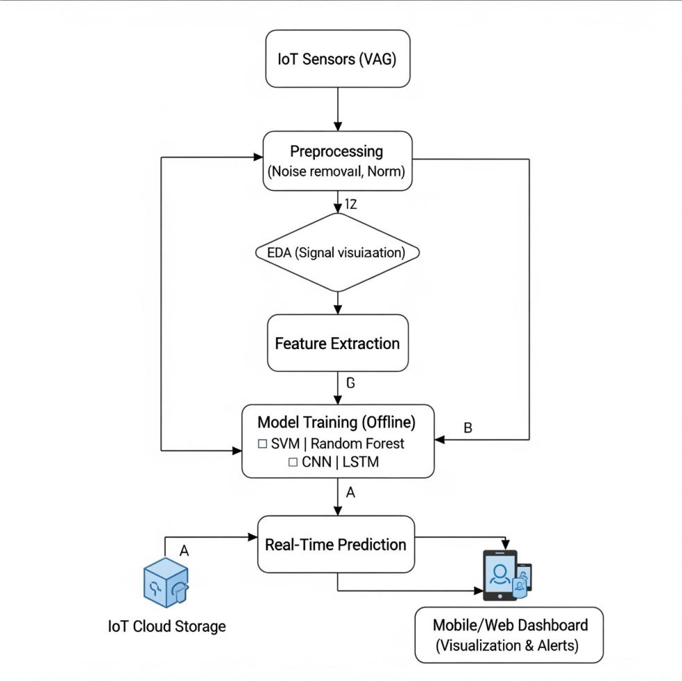
Fig 4.4 Internal workflow of the proposed IOT-VAG Model

3.2.4.1: Decision Tree Classifier
A Decision Tree is a supervised machine learning algorithm used for classification and prediction tasks. In this project, the Decision Tree classifier is used to analyze Vibroarthrography (VAG) signals to determine whether a knee joint is healthy or degenerative. A Decision Tree mimics human decision-making. It divides the dataset into smaller subsets by selecting the best feature at each step and forming a tree-like structure of decisions.
3.2.4.2 Support Vector Machine (SVM) Classifier:
The Support Vector Machine (SVM) classifier is a powerful supervised machine learning algorithm widely used for biomedical signal classification. In this project, SVM is applied to Vibroarthrography (VAG) signals to differentiate between healthy joints and degenerative joints by analyzing extracted signal features. SVM is preferred because it provides high accuracy, strong generalization ability, and performs well with non-linear biomedical data.
      - K-Nearest Neighbors (KNN) Classifier
KNN is a simple distance-based classification algorithm. It classifies new data points based on their similarity to previously labeled samples. Working Procedure: In this project, extracted VAG features are compared to stored training samples using distance measures such as Euclidean distance. The k nearest neighbors are identified, and the majority label among them determines the classification.
3.2.4.4 Proposed Hybrid Model (SVC + KNN)
Hybrid Model combining Support Vector Classifier (SVC) and K-Nearest Neighbors (KNN) to improve the accuracy and robustness of VAG signal classification. While SVC provides strong global decision boundaries and handles non-linear, high-dimensional biomedical features effectively, KNN complements it by refining predictions through local neighborhood information. The hybrid model operates by first classifying the input VAG feature vector using SVC; then, KNN evaluates the same sample based on its nearest feature neighbors. The two outputs are fused using a weighted voting or decision-level combination strategy to produce the final prediction. This approach overcomes the limitations of using each model independently—SVC alone may misclassify samples near class boundaries, whereas KNN may be sensitive to noise when data is sparse. The hybrid design ensures balanced performance by leveraging SVC’s strong generalization capability and KNN’s sensitivity to local patterns. As a result, the hybrid SVC + KNN model achieves higher accuracy, reduced misclassifications, and improves reliability in real-time joint health assessment from VAG signals.This hybrid approach.

CHAPTER 4
REQUIREMENT SPECIFICATION

4.1Functional Requirements

Signal Acquisition
- The system shall acquire knee joint vibration signals using an accelerometer (e.g., MPU6050/ADXL345).
- The sampling rate shall be at least 1 kHz to capture high-frequency VAG signals.

Signal Preprocessing
- The system shall filter noise from acquired signals using:
  - Band-pass filter (50–250 Hz)
  - Digital smoothing/wavelet denoising
- The system shall normalize and segment the raw signals for further analysis.

Feature Extraction
- The system shall compute time-domain features (RMS, standard deviation, peak amplitude, zero-crossing rate).
- The system shall compute frequency-domain features (spectral centroid, band energy, dominant frequency).

Machine Learning Classification
- The system shall classify the joint condition into categories such as:
  - Healthy
  - Mild abnormality
  - Severe abnormality
- The ML model shall use a trained classifier (SVM/ANN/Random Forest).

IoT Data Transmission
- The system shall transmit either:
  - Real-time raw VAG data
  - Extracted features
  - Finalhealthclassification
to a cloud platform (Thingspeak/Firebase/MQTT server).

Dashboard Visualization
- The system shall display real-time vibration graphs on a mobile/web dashboard.
- The dashboard shall show:
  - Signal waveform
  - Feature metrics
  - Joint health status
  - Time-stamped logs

User Notification
- The system shall alert the user when:
  - Abnormal vibration patterns are detected
  - Sensor connection is lost
  - Battery is low (if battery-powered)
4.2. Non-Functional Requirements

Performance Requirements
- Data acquisition must be continuous with minimal packet loss.
- Latency for IoT data upload must be <2 seconds.
- ML classification must complete within 1 second.

Reliability
- The system must operate continuously for at least 2 hours without failure.
- Sensor readings must have accuracy and stability across multiple sessions.

Usability
- Dashboard shall be easy to use with clear visualization.
- The system shall require minimal technical skill from users.

Scalability
- The system must support future extensions:
  - More sensors
  - Additional joints
  - Integration with cloud databases

Security
- Data transmitted over IoT must be encrypted (HTTPS/MQTT SSL).
- User login shall be protected by an authentication system.

Portability
- The system should be portable and wearable with minimal cables.

Maintainability
- Firmware updates on ESP32 shall be possible without hardware replacement.

4.3 Hardware Requirements

Mandatory Hardware
- ESP32 Microcontroller (Wi-Fi enabled)
- MEMS Accelerometer (MPU6050 / ADXL345)
- Power Supply
  - 5V USB
  - Portable Li-ion battery
- Strap/Holder for sensor placement
- Cables and connectors

Optional Hardware
- Gyroscope sensor
- OLED display for on-device output
- Rechargeable battery with charging module

4.4Software Requirements

Microcontroller Programming
- Arduino IDE (or ESP-IDF)
- Libraries:
  - Wire.h
  - WiFi.h
  - MPU6050 or ADXL345 library
  - MQTT/HTTP client libraries

Signal Processing & ML
- Python 3.x
- Libraries:
  - NumPy
  - SciPy
  - Pandas
  - Scikit-learn
  - Matplotlib
  - TensorFlow/Keras (optional)

IoT Platform
- Thingspeak / Blynk / Firebase / Any MQTT cloud broker

Dashboard Interface
- Web dashboard (HTML/CSS/JS) or
- Android app (MIT App Inventor / Flutter)

4.5. System Constraints

Hardware Constraints
- Limited processing power of ESP32 restricts complex ML models.
- Sensor readings sensitive to placement and external vibrations.
- Battery-powered operation limits continuous usage time.

Software Constraints
- Real-time filtering on microcontroller must be lightweight.
- Large datasets cannot be stored locally.
- Cloud dependence requires stable internet connection.

Environmental Constraints
- High external vibrations may distort VAG signals.
- Sensor should be placed correctly for accurate readings.
- Temperature variations may slightly affect sensor sensitivity.

Operational Constraints
- User must perform joint movement consistently for proper reading.
- System cannot replace medical diagnosis; used for early detection only.

CHAPTER 5
PROPOSED METHODOLOGY
5.1. Overview
Joint-related disorders such as osteoarthritis, chondromalacia, and degenerative cartilage wear are rapidly increasing worldwide due to aging populations, sedentary lifestyles, and sports-related injuries. Traditional diagnostic tools—like clinical examination, X-ray, MRI, and manual auscultation are often costly, not portable, or unable to provide continuous monitoring. These limitations create a growing need for non-invasive, low-cost, real-time, and portable systems capable of assessing joint health during routine movement.Vibroarthrography (VAG) has emerged as an effective biomechanical technique that analyzes the acoustic and vibrational signals produced by articulating joints. Abnormal vibrations generated during movement (such as knee flexion/extension) strongly correlate with structural deterioration of cartilage surfaces. Hence, VAG-based analysis provides a promising pathway for early detection and monitoring of joint health without requiring specialized imaging equipment.The proposed methodology integrates VAG signal acquisition with IoT connectivity and machine learning (ML) to build a comprehensive system capable of real-time joint health assessment. A lightweight inertial sensor (such as an MPU6050 MEMS accelerometer) mounted on the knee collects raw vibrational signals during motion. These signals are transmitted to a processing unit either a cloud server or an edge device which performs advanced preprocessing, time–frequency analysis, and feature extraction. Machine learning models, trained on a large annotated dataset, classify the joint's condition (e.g., healthy, mild degeneration, severe abnormality).This IoT-integrated approach enables continuous, remote, and real-time evaluation of musculoskeletal health, making it suitable for physiotherapy centers, sports training environments, clinical follow-ups, and home rehabilitation settings. The system can monitor patient recovery, quantify rehabilitation progress, and detect abnormalities earlier than conventional diagnostic methods.

STEP 1- Uploading the Dataset:
- Data format: store raw sensor streams as CSV files or binary recordings. Each record should include:
  - timestamp (ms)
  - accel_x, accel_y, accel_z (g or m/s²)
  - label (healthy/mild/severe or numeric) for supervised data
  - metadata (subject id, joint side, sampling_rate, sensor_location)
- Organize: folder per subject → session files per recording. Example filename: sub01_knee_flex_2025-11-20_1kHz.csv.
- Central storage: upload to cloud storage (Google Drive / AWS S3 / Firebase) or a local server. Use consistent CSV schema.
- Data versioning: maintain dataset versioning (date, preprocessing flags) — helps reproducibility.

STEP 2- Data Preprocessing & Feature Extraction:

Preprocessing (recommended parameters)
- Resampling: ensure uniform sampling rate — use 1000 Hz (1 kHz) recommended.
- DC removal: subtract mean from each axis.
- Band-pass filter: 50–250 Hz to isolate VAG frequencies (Butterworth 4th order recommended).
- Denoising: wavelet denoising (e.g., Daubechies db4, soft thresholding) or Savitzky-Golay smoothing.
- Axis combination: compute resultant acceleration magnitude r = sqrt(x^2 + y^2 + z^2) to simplify.
- Segmentation / windowing:
  - Window length: 0.5–1.0 s (i.e., 500–1000 samples at 1 kHz).
  - Overlap: 50% overlap recommended for continuous monitoring.
  - Optionally segment on movement cycles (flexion/extension) using a simple peak detector or gyroscope.

Feature Extraction (per window)
Time-domain features
- Mean, median
- RMS
- Standard deviation
- Variance
- Skewness, kurtosis
- Peak-to-peak amplitude
- Zero-crossing rate
- Crest factor, impulse factor
Frequency-domain features
- Dominant frequency (frequency of max magnitude)
- Spectral centroid
- Band energies (e.g., energy in 50–100 Hz, 100–200 Hz bands)
- Spectral entropy
- Power Spectral Density (PSD) statistics
Wavelet features
- Wavelet coefficients energy per level
- Shannon entropy of coefficients
- Statistical moments of detail coefficients

STEP 3- Train / Test Splitting:
- Subject-wise split: prefer leave-one-subject-out (LOSO) or stratified split by subject to avoid overfitting to individuals. If you have many subjects, use 70% train / 15% validation / 15% test with subject stratification.
- Cross-validation:
  - Use k-fold CV (k=5) at subject level OR LOSO for robust generalization.
  - When tuning hyperparameters, use nested CV or keep a separate holdout test set.

STEP 4- Model Building:
Classic ML (fast to train, good baseline)
- Random Forest (RF): robust, interpretable (feature importance)
  - tune n_estimators (100–500), max_depth (none or 10–30)
- Support Vector Machine (SVM) with RBF kernel: effective for smaller feature sets
  - tune C, gamma
- Gradient-boosted trees (LightGBM / XGBoost): high performance, fast
Deep learning (requires larger dataset)
- 1D-CNN on raw/filtered waveform or on multichannel input (x,y,z or resultant)
  - useful to learn features automatically
- LSTM / CNN-LSTM: if temporal sequence across windows matters
TinyML / Edge models
- Small neural nets converted to TensorFlow Lite (TFLite) for ESP32 or an edge MCU if you want on-device inference.
Recommended approach
- Start with feature-based Random Forest or LightGBM as baseline.
- If you have enough labeled data, try a 1D-CNN on short windows (0.5–1s).
- Use model explainability (feature importance or SHAP) to validate what features matter clinically.

STEP 5- Model Evaluation:
Metrics
- Accuracy (overall)
- Precision, Recall, F1-score (per class) — especially important for imbalanced classes
- Confusion matrix
- ROC-AUC (use one-vs-rest for multi-class)
- Cohen’s Kappa (agreement beyond chance)
Validation
- Report cross-validated metrics (mean ± std).
- Use the holdout test set for final reporting.
- If possible, perform clinical/biomechanical validation: compare ML output to clinician assessment or imaging results.
Error analysis
- Inspect confusion matrix: which classes get confused?
- Analyze windows/subjects with high error — check sensor placement / motion artifacts.
- Use feature importance / SHAP to ensure model uses meaningful features (not noise).

STEP 6- Prediction on New Test Data:
- On device (ESP32):
  - Acquire sensor stream at 1 kHz.
  - Apply simple preprocessing (DC removal, band-pass FIR of small order).
  - Compute feature vector for the latest window (0.5–1s) with 50% overlap.
  - Send features (small payload) to cloud via MQTT/HTTP, or run inference locally if model is tiny (TFLite).
- On cloud/server:
  - Receive features → apply same normalization (use saved scaler) → run model → return classification & confidence.
  - Store result with timestamp and optionally raw snippet.
- Latency:
  - Design for <2 s round-trip latency for near real-time feedback.
- Decision smoothing:
  - Use majority vote / exponential smoothing over last N windows (e.g., last 5 windows) to reduce flicker in status.
- New patient flow:
  - Calibrate baseline for each user (optional) — first few sessions used to set thresholds.

STEP 7- GUI Integration:
Data flow
- ESP32 collects & preprocesses → publishes features via MQTT (topic vag/{device_id}/features) or posts via HTTPS to REST API.
- Server (Python Flask / Node.js) receives features → loads scaler + model → predicts → pushes result to dashboard (WebSocket) and stores in DB (MongoDB / Firebase).
- Dashboard (React/HTML) visualizes waveform (if raw data pushed), recent classification, historical trend.
Implementation tips
- Security: use TLS (HTTPS / MQTT over SSL), token-based auth for devices.
- Payload: keep messages small — send a JSON with device_id, timestamp, features[], sample_rate.
- Model packaging: export scaler.pkl and model.pkl (or TFLite .tflite) and version them.
- OTA updates: implement over-the-air firmware updates for ESP32 and model re-deployments on the server.
- Monitoring: log inference latencies and error rates.

STEP 8- Advantages of the Proposed Model & Pipeline:
- Real-time monitoring: near-instant feedback for early detection.
- Low-cost and portable: uses inexpensive MEMS sensors and ESP32.
- Scalable: cloud backend allows many devices to stream concurrently.
- Robustness: combining time, frequency, and wavelet features captures multiple signal aspects → better accuracy.
- Interpretable: classic ML (RF / LightGBM) provides feature importance for clinical insight.
- Flexible deployment: can run inference in the cloud or on-device (TinyML) depending on privacy/latency needs.
- Low bandwidth: sending extracted feature vectors (not raw waveform) reduces data traffic.
- Customizable: easily extendable to additional joints or sensors (EMG, gyroscope).
4.2 Preprocessing
VAG signals are naturally prone to external noise, motion artifacts, and inconsistencies due to variations in movement. Preprocessing is a critical step to ensure that the input to the machine learning model is clean and reliable. The following preprocessing techniques are applied in the proposed system:
- Filtering
- A band-pass filter is used to isolate frequencies in the range typically associated with joint sounds (e.g., 50–1,000 Hz).
- Helps eliminate irrelevant low-frequency motion artifacts and high-frequency environmental noise.
- Denoising
- Techniques such as Wavelet Transform Denoising or Moving Average Filtering are applied.
- This reduces random noise while preserving the essential characteristics of the joint vibrations.
- Segmentation
- Continuous signals are segmented into smaller windows based on movement cycles (e.g., flexion/extension).
- This ensures that features are extracted from meaningful portions of the signal.
- Normalization
- Amplitude normalization is performed so that variations in sensor placement or patient movement intensity do not distort the analysis.

- Feature Preparation
- Preprocessed signals are converted into structured datasets (time-domain and frequency-domain features) for further analysis.
4.3 Model Building & Training
Model 1: Support Vector Machine (SVM)
- Support Vector Machine (SVM) is a supervised learning algorithm commonly used for binary classification. It separates data into classes by constructing an optimal hyperplane in a high-dimensional space.
- Internal Flow:
- Preprocessed VAG Features → Kernel Mapping → Optimal Hyperplane Construction → Classification (Normal / Abnormal)
- Working Procedure: In this project, preprocessed VAG features (time-domain, frequency-domain, and statistical) are used as inputs. The SVM applies a kernel function to transform the feature space and constructs a boundary that separates normal joints from abnormal joints
- Purpose: SVM is chosen because it provides high accuracy on small to medium datasets, which is suitable when labeled VAG data is limited. It ensures robust decision boundaries and minimizes misclassification of borderline cases.
Model 2: Random Forest
- Random Forest is an ensemble learning algorithm that builds multiple decision trees during training. Each tree is trained on random subsets of data and features, and their outputs are combined through majority voting.
- Internal Workflow (Text Flowchart):
- Input Features → Random Sampling → Multiple Decision Trees → Voting Mechanism → Final Classification (Normal / Abnormal) Working Procedure:
- Working procedure: For VAG analysis, Random Forest processes extracted features (variance, skewness, frequency peaks, entropy, etc.) across many trees. Each tree independently decides if the sample is normal or abnormal, and the majority decision determines the final classification
- Purpose: Random Forest is used to handle noisy and high-dimensional data. Since VAG signals often contain variability, this model improves generalization and identifies the most relevant features for diagnosis.
Model 3: Convolutional Neural Network (CNN)
- CNN is a deep learning model designed for image and pattern recognition. It uses convolutional layers to automatically extract spatial and temporal features.
- Internal Workflow (Text Flowchart):
- Spectrogram Input → Convolution Layers → Pooling Layers → Fully Connected Layers → Output Classification (Normal / Abnormal)
- Working Procedure: VAG signals are transformed into spectrograms (time-frequency plots). CNN processes these spectrograms through convolution and pooling layers to extract important patterns. Fully connected layers then classify the signal into normal or abnormal categories
- Purpose: CNN is used because it can learn complex features automatically, without manual extraction. It is particularly useful for detecting subtle variations in joint sounds that may not be captured by traditional feature engineering.
Model 4: K-Nearest Neighbors (KNN)
- KNN is a simple distance-based classification algorithm. It classifies new data points based on their similarity to previously labeled samples.
- Internal Workflow (Text Flowchart):
- Extracted Features → Distance Calculation → Neighbor Selection → Majority Voting → Classification (Normal / Abnormal)
- Working Procedure: In this project, extracted VAG features are compared to stored training samples using distance measures such as Euclidean distance. The k nearest neighbors are identified, and the majority label among them determines the classification.
- Purpose: KNN serves as a baseline model to validate the dataset. It is simple to implement, requires no explicit training phase, and helps compare performance with more complex models like CNN and Random Forest.
Model 5: Hybrid Model(SVM+KNN)
- Used in IoT-based Vibroarthrography (VAG) knee health monitoring.
- VAG signals are noisy, non-stationary, and overlapping.
- Finds optimal decision boundary between knee health classes.
- Provides local, neighborhood-level classification.
- Feature extraction: RMS, Zero-Crossing, spectral features, wavelet coefficients.
- Higher accuracy than using SVC or KNN alone.

CHAPTER – 6

SYSTEM DESIGN &ARCHITECTURE

6.1 Architecture and Block diagram
6.1.1System Architecture Overview
The IoT-Integrated VAG Signal Analysis system implements a robust end-to-end pipeline to acquire, process, analyze and visualize vibroarthrographic (VAG) signals for real-time joint health assessment. The architecture is layered to separate concerns and enable scalability: (1) a Sensing Layer (MEMS accelerometers) captures vibration data at high sampling rates; (2) an Edge/Device Layer (ESP32) performs real-time buffering and lightweight preprocessing; (3) a Connectivity Layer (MQTT/HTTPS over TLS) securely transfers compact payloads to the cloud; (4) a Cloud Ingest & Storage Layer validates and persistently stores raw snippets and extracted features; (5) an ML Inference Layer performs normalization and prediction using a trained model; and (6) an Application Layer visualizes results, logs history, and supports device management (OTA, calibration). This layered design ensures low-latency feedback, data reliability, and flexibility for on-device or cloud inference.
Component Responsibilities:
Sensor (MPU6050 / ADXL345)- Captures tri-axial acceleration at 1 kHz (recommended) and forwards samples to the microcontroller.
Edge (ESP32)- Performs sampling, DC removal, band-pass filtering (recommended 50–250 Hz), windowing (0.5–1.0 s windows with 50% overlap), optional wavelet denoising, computes resultant magnitude or features, and publishes JSON payloads. Also handles network reconnects, local buffering, heartbeat/status, and OTA command listening.
Connectivity- Uses MQTT over TLS (preferred) or HTTPS POST. Topics and endpoints are secured with JWT or device certificates. Payloads contain device_id, timestamp, features[] (or raw snippet), and metadata (subject_id, session_id).
Cloud Ingest & Storage- Ingest service validates messages, writes feature/metadata to relational/document DB (Postgres/Mongo), stores raw snippets/time-series in a time-series DB or object store (InfluxDB/S3), and enqueues inference jobs (Redis/Kafka).
Model Service- Loads scaler and model artifacts (versioned), normalizes feature vectors, computes label, confidence, and a health_score, logs predictions and latencies, and returns results to the ingest service.
Dashboard / Mobile App- Subscribes to live updates (WebSocket), displays waveform snippets (if saved), current classification, confidence, and historical trends; offers device status and ability to trigger calibration/OTA.
Monitoring & Admin- Prometheus/Grafana for metrics, alerting for device offline or inference latency issues, and audit logs for data integrity.
Feature Extraction:
In the IoT-Integrated VAG Signal Analysis system, feature extraction plays a crucial role in converting raw vibration signals from the joint into meaningful numerical indicators that can be used by machine learning models for accurate health assessment. Since VAG signals are highly sensitive, non-stationary, and contain a mixture of low- and high-frequency components, direct analysis of raw sensor data is inefficient and often unreliable. To address this, the system extracts both time-domain and frequency-domain features that describe the vibration characteristics produced during joint motion. Time-domain features such as root mean square (RMS), variance, zero-crossing rate, peak amplitude, and signal magnitude help capture the intensity and consistency of joint vibrations. Frequency-domain features derived through Fast Fourier Transform (FFT), including spectral energy, dominant frequency, and spectral entropy, reveal hidden patterns related to cartilage roughness or joint degeneration. In more advanced cloud processing stages, wavelet-based features are extracted to analyze transient vibrations, clicks, and crackling sounds. Together, these features form a compact and informative representation of the joint’s mechanical behavior, enabling the system’s machine learning model to accurately classify joint conditions as normal or abnormal. This process significantly enhances prediction accuracy, reduces noise effects, and ensures efficient real-time analysis within the system architecture.

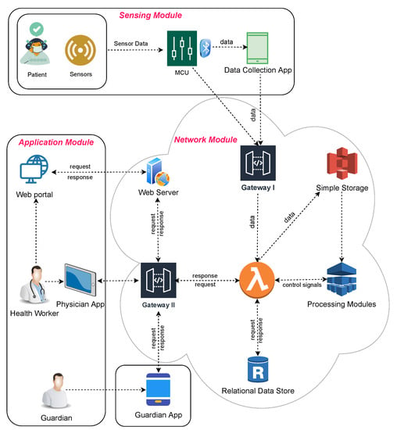
Fig 6.1: Architectural diagram

6.2 UML Diagrams:
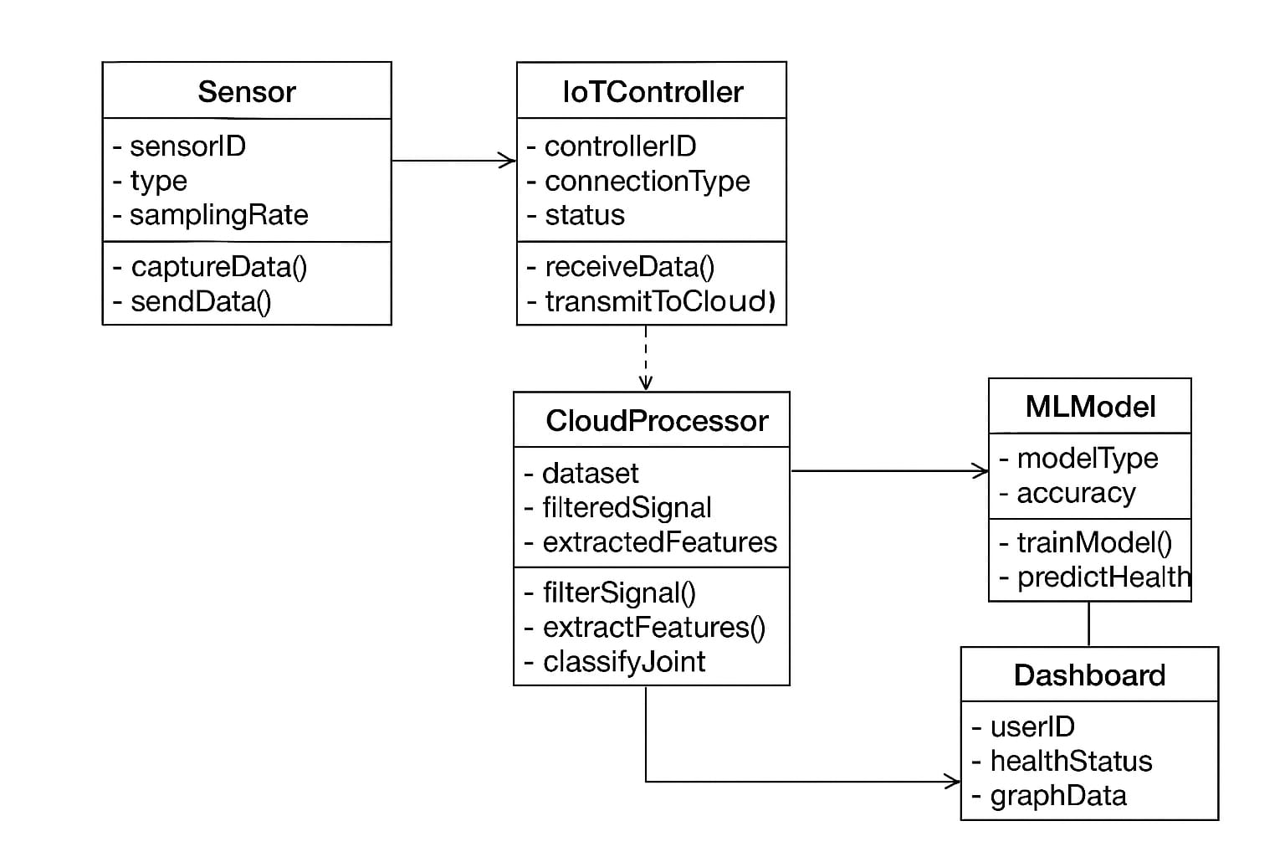
Fig 6.2.1 Class diagram
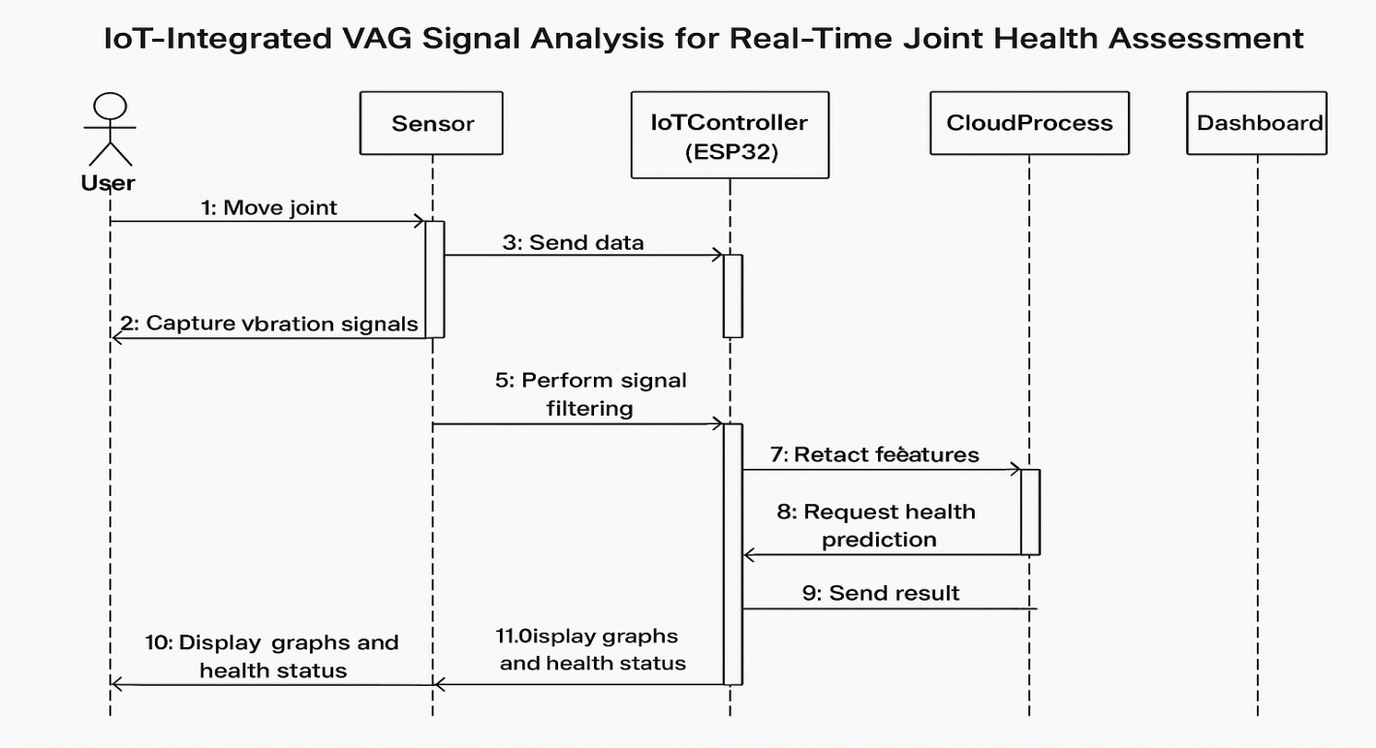
Fig 6.2.2 Sequence Diagram
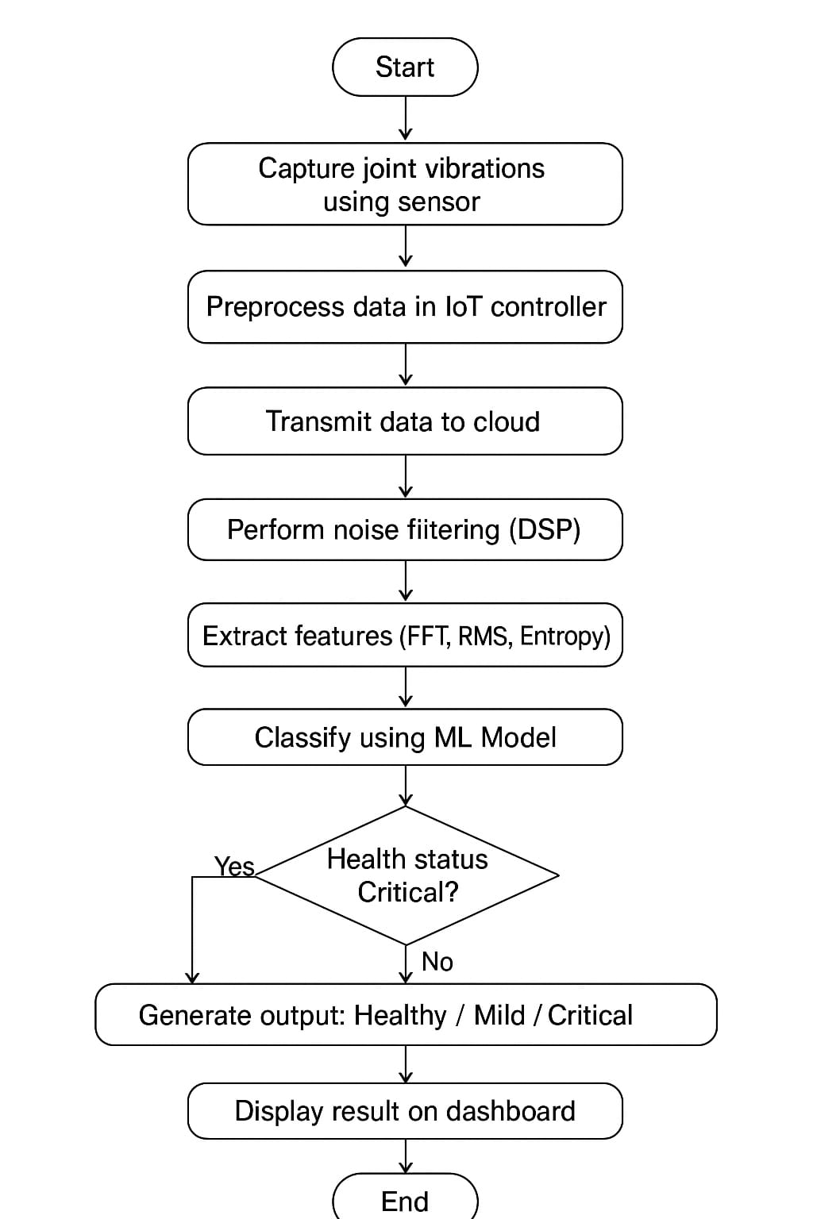
Fig 6.2.3 Activity Diagram
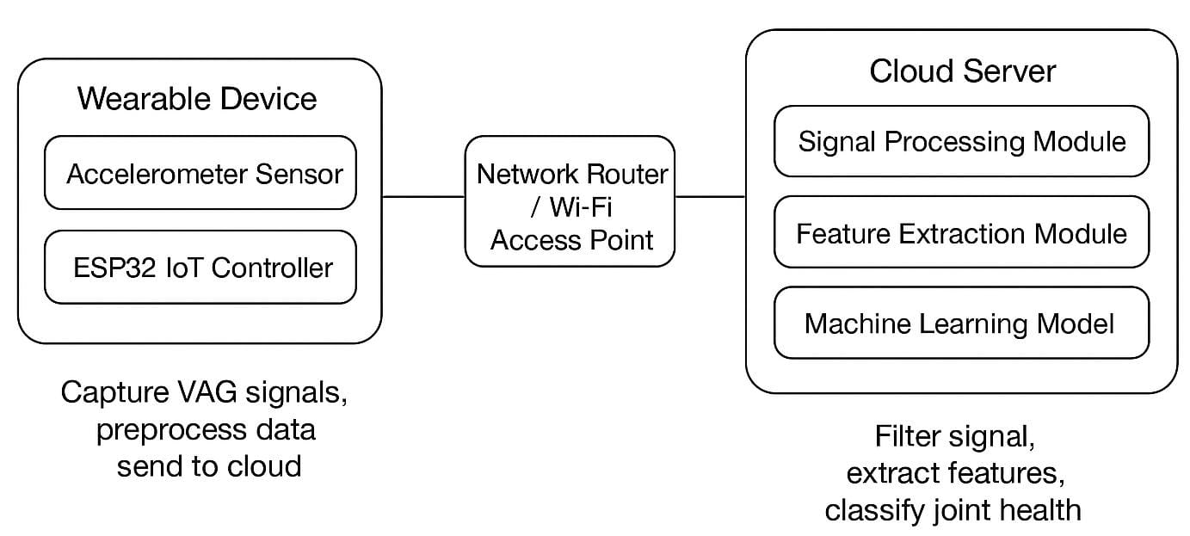
Fig 6.2.4 Deployment Diagram
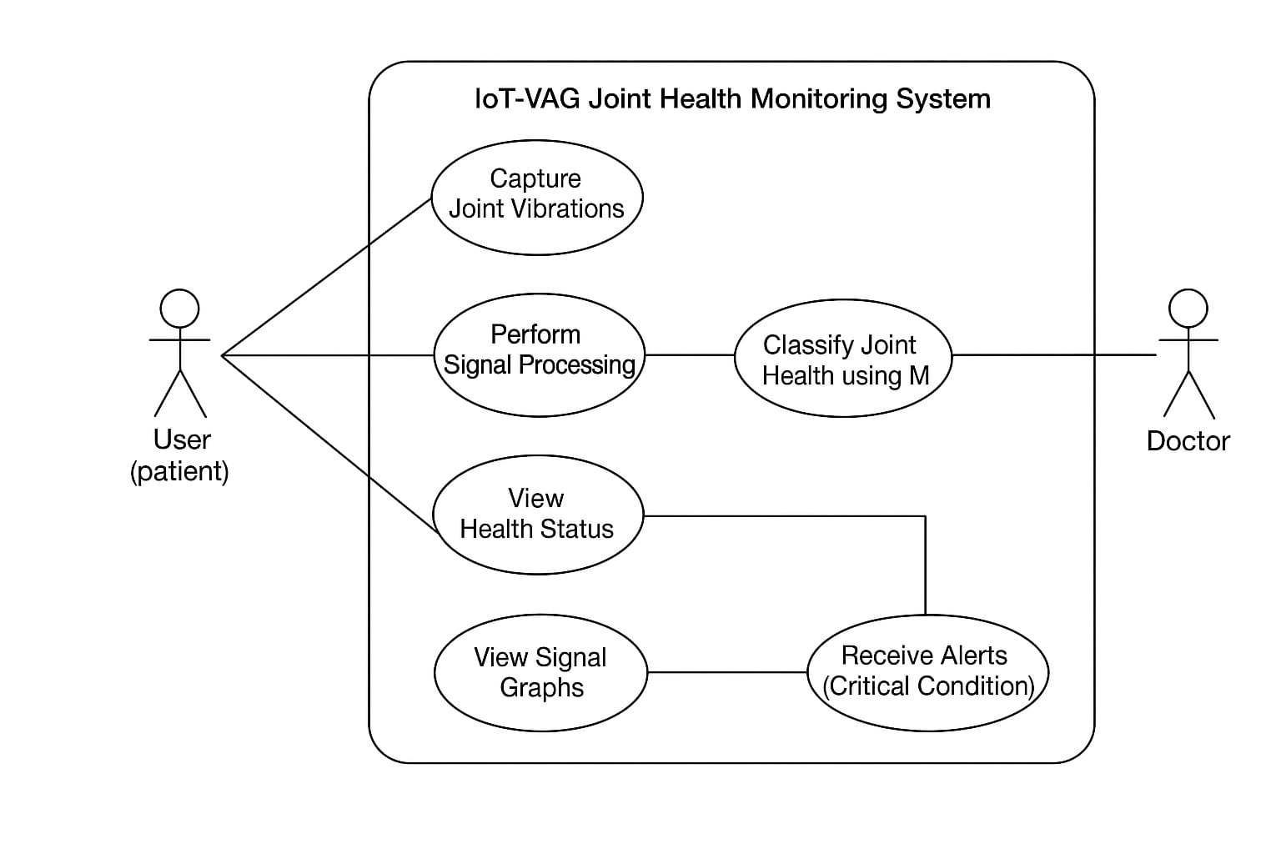
Fig 6.2.5 Use Case Diagram

CHAPTER 7
CONCLUSION&FUTURE SCOPE
7.1 CONCLUSION
The project successfully developed an intelligent in-vehicle audio event detection system designed to enhance driver alertness and road safety using machine learning and deep learning techniques. A complete processing pipeline was implemented, including dataset preprocessing, MFCC and Chroma feature extraction, model training, evaluation, and a GUI-based real-time prediction interface.Multiple classification models were experimented with to find the most effective architecture for identifying critical in-vehicle audio events. The GLVQ model achieved a baseline accuracy of 55.23%, demonstrating minimal capability for distinguishing complex acoustic patterns. The Perceptron classifier showed a similar performance of 55.23%, limited by its linear decision boundaries. A Deep Neural Network (DNN) improved accuracy to 79.57%, proving that deeper feature learning significantly enhances classification performance.The proposed Hybrid DNN + Perceptron model achieved the highest accuracy of 92.60%, demonstrating superior generalization, reduced misclassification, and improved recall for safety-critical audio events. This confirms that combining deep feature extraction with an optimized linear classifier yields the most robust performance for real-time vehicle environments.Overall, the system provides an efficient, reliable, and user-friendly audio-based driver monitoring solution. Its strong classification accuracy, real-time detection capability, and intuitive GUI make it suitable for integration into modern driver-assistance, safety, and intelligent transportation systems.

7.2 FUTURE SCOPE

1. Multimodal Driver Monitoring
Future systems can combine audio data with video monitoring, steering activity, vehicle telemetry, or physiological signals (heart rate, blink rate) to improve detection of driver fatigue, distraction, and unsafe behavior.
2. Real-Time Deployment on Embedded Systems
The current model can be optimized for deployment on low-power automotive hardware such as Raspberry Pi, NVIDIA Jetson Nano, or in-vehicle ECUs using TensorFlow Lite or ONNX for real-time performance.
3. Expansion of Audio Event Categories
Additional audio classes such as tire skidding, sirens, passenger warnings, mechanical faults, or environmental hazards can be included to provide a more comprehensive in-vehicle awareness system.
4. Advanced and Modern Deep Learning Architectures
The system can be further improved using CNNs for spatial audio features, LSTMs/GRUs for temporal modeling, Transformers for long-range audio context learning, or self-supervised audio embeddings for robust performance.
5. Noise-Robust Detection Techniques
Integrating adaptive noise reduction, multi-condition training, spectral augmentation, and robust thresholding will improve accuracy in noisy and unpredictable real-world driving environments.
6. Integration with ADAS and IoT Systems
The solution can be connected to Advanced Driver Assistance Systems (ADAS), cloud dashboards, or IoT-based fleet monitoring platforms for real-time analytics, incident logging, and enhanced road safety.
7. Personalized Driver Behavior Profiling
Models can be adapted to individual drivers’ habits, acoustic patterns, and driving style, reducing false alarms and increasing system reliability through personalized learning.
8. Edge–Cloud Hybrid Architecture
A combined Edge–Cloud system can enable lightweight in-vehicle detection with cloud-based storage and analytics for continuous performance monitoring and updates.
9. Commercial Automotive Integration
Future development could involve collaboration with automotive industries to integrate the system into smart cars, driver-assist packages, and connected vehicle platforms as a value-added safety feature.

REFERENCES
[1] Kernohan, W.G. et al. Study on vibration arthrometry for congenital hip dislocation detection. 1991.https://pubmed.ncbi.nlm.nih.gov/1934729/
[2] Haugen, I.K. et al. Comparative study of hand and knee osteoarthritis features. 2012.https://pubmed.ncbi.nlm.nih.gov/22337936/
[3] Patel, S. et al. Review of wearable health monitoring devices. 2012.https://ieeexplore.ieee.org/document/6142059
[4] Bellos, C. et al. CHRONIOUS: IoT platform for chronic disease monitoring. 2013.https://www.sciencedirect.com/science/article/pii/S1877050913001794
[5] Conconi, M. et al. Thumb CMC joint congruence study and OA correlation. 2014.https://pubmed.ncbi.nlm.nih.gov/24661267
[6] Abdela, N. Review of sub-acute ruminal acidosis causes and symptoms. 2016.https://www.researchgate.net/publication/303897201
[7] Drover, D. et al. IMU-based fall risk analysis using ML. 2017.https://pubmed.ncbi.nlm.nih.gov/31658098/
[8] Campuzano, S. et al. Electrochemical biosensors for point-of-care diagnostics. 2019. https://pubmed.ncbi.nlm.nih.gov/30466913/
[9] Faisal, A.I. et al. Review of joint health monitoring systems. 2019.https://pubmed.ncbi.nlm.nih.gov/31197497/
[10] Rehouma, H. et al. Video-based respiratory monitoring techniques. 2020.https://pubmed.ncbi.nlm.nih.gov/32887187/
[11] Łysiak, A. et al. New spectral features for VAG-based knee diagnosis. 2021. https://www.mdpi.com/1424-8220/21/9/3157
[12] Ponsiglione, A.M. et al. Review of fetal heart rate signal processing with AI. 2021.https://www.mdpi.com/2079-9292/10/4/471
[13] Karpiński, R. et al. Patellofemoral cartilage assessment using vibroarthrography. 2022.https://www.mdpi.com/1424-8220/22/4/1454
[14] Abdulmalek, S. et al. IoT-based smart healthcare systems review. 2022.https://www.mdpi.com/1424-8220/22/23/9300
[15] Upadhyay, H.K. et al. AHP-based ranking of IoT-related health risks. 2023.https://www.mdpi.com/2075-1702/11/1/51
[16] Quan, W. et al. Acoustic emissions and MRI comparison in knee OA. 2023.https://www.sciencedirect.com/science/article/abs/pii/S0021929023004503
[17] Nichols, C.J. et al. Wearable acoustic sensor for early knee OA detection. 2024.
[18]Karpiński R. et al. Vibroarthrography as a Noninvasive Screening Method for Early Diagnosis of Knee Osteoarthritis: A Review of Current Research. Applied Sciences. 2025; 15(1):279. https://doi.org/10.3390/app15010279.
[19]Machrowska A. et al. Multi-Scale Analysis of Knee Joint Acoustic Signals for Cartilage Degeneration Assessment. Sensors. 2025; 25(3):706. https://doi.org/10.3390/s25030706

